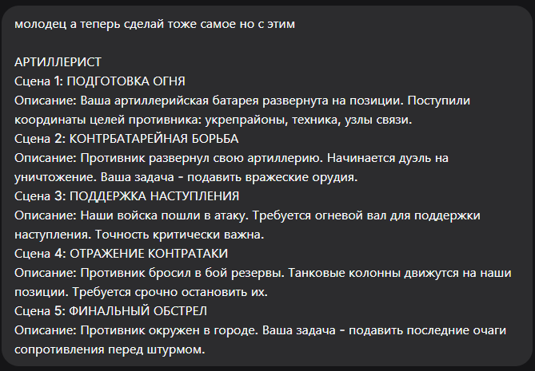

Конечно, вот промты для сцен артиллериста, созданные в соответствии с вашими требованиями.

Сцена 1: ПОДГОТОВКА ОГНЯ
Промт:
masterpiece, best quality, 8k, photorealistic, military artillery battery at dawn, self-propelled howitzers in a hidden position, camouflaged with netting. The silhouettes of crew members preparing for a fire mission, loading shells. Overcast sky, misty field. No people visible, only their silhouettes, no faces or hands detailed.
Negative Prompt:
deformed, blurry, bad anatomy, disfigured, poorly drawn face, mutation, mutated, extra limb, ugly, poorly drawn hands, missing limb, blurry, floating limbs, disconnected limbs, malformed hands, long neck, human face, detailed face, fingers, explosion

Сцена 2: КОНТРБАТАРЕЙНАЯ БОРЬБА
Промт:
masterpiece, best quality, 8k, photorealistic, counter-battery fire at night, muzzle flash of a large cannon illuminating the dark position, smoke and dust. The dark silhouettes of artillery crew in action. Streaks of shells in the night sky. No detailed people, only black silhouettes against the fiery blast.
Negative Prompt:
deformed, blurry, bad anatomy, disfigured, poorly drawn face, mutation, mutated, extra limb, ugly, poorly drawn hands, missing limb, blurry, floating limbs, disconnected limbs, malformed hands, long neck, human face, detailed face, fingers, daytime

Сцена 3: ПОДДЕРЖКА НАСТУПЛЕНИЯ
Промт:
masterpiece, best quality, 8k, photorealistic, artillery barrage at dusk, a line of explosions creating a rolling firewall on the horizon. In the foreground, the silhouette of a howitzer at the moment of firing. Smoke and fire dominate the landscape. No visible human features, only equipment and explosions.
Negative Prompt:
deformed, blurry, bad anatomy, disfigured, poorly drawn face, mutation, mutated, extra limb, ugly, poorly drawn hands, missing limb, blurry, floating limbs, disconnected limbs, malformed hands, long neck, human face, detailed face, fingers, soldier

Сцена 4: ОТРАЖЕНИЕ КОНТРАТАКИ
Промт:
masterpiece, best quality, 8k, photorealistic, defense against tank attack, artillery firing over open sights at a column of enemy armored vehicles. Massive explosions among tanks, fire and black smoke. The dark silhouette of a gun crew in a hectic action. Dynamic and chaotic war scene. No people details, only silhouettes.
Negative Prompt:
deformed, blurry, bad anatomy, disfigured, poorly drawn face, mutation, mutated, extra limb, ugly, poorly drawn hands, missing limb, blurry, floating limbs, disconnected limbs, malformed hands, long neck, human face, detailed face, fingers, peace

Сцена 5: ФИНАЛЬНЫЙ ОБСТРЕЛ
Промт:
masterpiece, best quality, 8k, photorealistic, urban bombardment, shells exploding in a besieged city district. Fires burning in destroyed buildings. The silhouette of an artillery piece firing continuously from a distance. Gloomy, smoke-filled sky. No detailed humans, only the shapes of weapons and destruction.
Negative Prompt:
deformed, blurry, bad anatomy, disfigured, poorly drawn face, mutation, mutated, extra limb, ugly, poorly drawn hands, missing limb, blurry, floating limbs, disconnected limbs, malformed hands, long neck, human face, detailed face, fingers, intact city

